Product Specification File and Inspection Criteria
Section 1 – General Product Details and Description
Section 2 – Product Performance Specification & Critical Component List
Section 3 – Packaging
Section 4 – Labelling
Section 5 – Documentation
Section 6 – Product Finish
Section 7 – Visual Inspection Criteria
Section 8 – Product Test Criteria
Section 9 – fault points should be corrected in the production

The green marked part is original parameter, which shall be replaced by yellow part, the yellow part should be checked by each batch according to IEC standard.

Legend
U₀- Rated no-load voltage
U₁- Rated input voltage
U_{2min}- Min output voltage
U_{2max}- Max output voltage
I₁- Rated input current
I_{2min}- Min welding current
I_{2max}- Max welding current

Product Identification
Vendor Name | HANKER | Cust Product Code |  | Created | 19.11.2019
Factory Name | HANKER | Cust Product Designation | DRIVE INMIG DW SYN PULSE | Last Modified
Supplier Item Code | DUAL PULSE WIRE FEEDER | Cust Brand | Fubag | Revision | v.1.0

Revision List
Revision Ref | Date of Revision | Description of Revision

Section 1 – General Product Details and Description
General Product Description
External wire feeder for source model: INMIM500TDW SYN PULSE, max 500A, Steel wire feeder, Steel Chassis. Rollers into wire feeder should be V-type (for solid wire) 1.0/1.2mm.
Accessories (Packing List) | User manual.

Standards
Destination Market | Russia | Destination Market Spec |  | 380V/50 Hz
Criteria | Standard |  | Certificate Number

Product Image
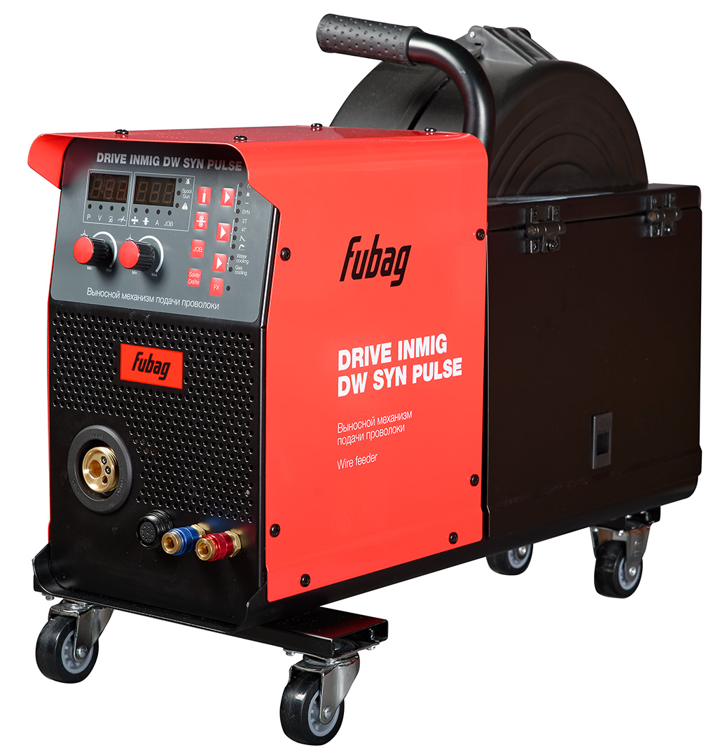

Section 2 – Product Performance Specification & Critical Component List
Product Performance Specification
Description (DC 24V)  (Wire feeder) | Value & unit  (Ambient temperature) |  | Tolerance | Reference to  GOST EN60974-1-2012
Description (DC 24V)  (Wire feeder) | 20°C | 40°C | Tolerance | Reference to  GOST EN60974-1-2012
Wire diameter | 0.6…1.6mm | 0.6…1.6mm
Power safety device Max Input current (I1max), A | 3.5A | 3.5A
Max output speed | 18m/min | 18m/min
Min output speed | 1.5m/min | 1.5m/min
Max welding current | 500A | 500A
Power of motor | 84W | 84W
Traction | 280N | 280N
Open Circuit Voltage (NO LOAD Voltage), V | 0V | 0V
Voltage at max current, V | 24V | 24V
Voltage at min current, V | 2.4V | 2.4V
Thermostat activation time, load 500A | 6min | 6min
Welding current at Duty Cycle 100%, А | 400A | 400A
Duty Cycle at maximum current | 60% | 60%

Specification
 | Description |  | Control level (classification)
 | Test marks: | N/A | Major
 | Certification | CE / GS / UL / CSA/ ETL | Major
 | EC directives | MD / EMC / LVD Emission / NOISE / PAH / ROHS | Major
 | Marking of Electrical and electronic equipment in according with Article 11(2) of Directive 2002/96/EC (WEEE); German version EN 50419: 2004 EN 50419: 2004  2002/96/EC (WEEE)， 11(2) | N/A  According to IEC/EN 60974 | Major

Packaging
 | Description | Spec | Control level (classification)
 | Thickness (mm) | TBA | Major
 | Tile | Double-wall corrugate | Major
 | Surface treatment | TBA | Major
 | Connector type | Split top box | Major
 | Inlay material | Polyfoam 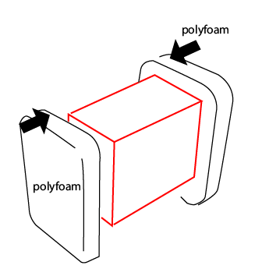 | Major
 | Accessories package | No | Major
 | Quantity | 1 | Major
 | Packing Strap | no | Major
 | Bar code | yes | Major
Critical Component List
Item No. as per Parts List | Code | Description | QTY | Results
1 | 7.0510.1802-FA | Right panel | 1
2 | 7.0500.1802-FA | Left panel | 1
3 | 6.6860.001 | Locker | 2
4 | 6.8030.201 | wire feeder axis | 1
5 | 7.3040.004 | double drive Wire feeder cover | 1
6 | 6.8030.001 | wire feeder container | 1
7 | 6.7100.102-A | double drive Wire feeder device | 1
8 | 7.1230.904 | double drive Wire feeder bottom plate | 1
9 | 3.P628.4008 | front panel | 1
10 | 6.4580.005-R | knob | 2
11 | 7.7130.032 | insulation plate | 1
 | 7.7130.033 | insulation plate | 1
12 | 7.1770.001 | Connector | 1
13 | 7.1780.002 | Wire connector | 1
14 | 6.6670.001 | Central socket | 1
15 | 6.6820.001 | universal wheel | 2
16 | 6.1320.009-A | 9 pin socket | 1
17 | 7.4620.202 | socket (red) | 2
18 | 7.4620.203 | socket (blue) | 2
19 | 7.1230.135-A | fixing plate | 1
20 | 7.0550.1802-FA | bottom plate | 1
21 | 7.3030.1801-FA-A | Assembly sheet | 1
22 | 3.P628.7010-A | torch panel | 1
23 | 6.6820.101 | fixed wheel | 2
24 | 7.1230.136-A | fixing plate | 1
25 | 7.0680.1802-FA-A | rear panel | 1
26 | 6.1520.201 | euro socket (without plastic cover) | 1
27 | 6.1320.414 | 14 pin socket | 1
28 | 7.4620.005 | Gas fitting | 1
29 | 7.3070.1802-FA | sealing plate for rear panel | 1
30 | 6.6860.100 | hinge | 4
31 | 6.2530.002 | Gas valve | 1
32 | 7.3030.1802-FA-A | Assembly sheet | 1
33 | 7.0620.0801 | fixing plate for PCB | 1
34 | 3.P628.5003-B | drive panel | 1

Exploded view
Section 3 – Packaging
Package
Packaging Description
Colour Fubag sticker on Box with DRIVE
Packaged Dimensions, LWH, mm | 820x460x560
Gross Weight/Net Weight | 21.5/19 | Bar code
Pcs per Outer | 1 | Pcs Per Inner | N/A
Outer Carton Material Spec | Color 5-layer carton, thickness min. 5mm | Inner Carton Material Spec | N/A
Shipping Mark & Spec (Font Size Etc)
Poly Bag Spec and Warning Labels

Section 4 – Labelling
Labelling Requirements
Specification and model name

Side silkscreen

Front panel sticker

Door inside sticker
Front side silkscreen
Section 5 – Documentation
Document List
Document No. | Description
1. | User Manual

Document No. 1 Specification
Doc Name/Desc | User Manual
No of Pages |  | Size | 148*210 (A5) | Description/Style | Leaflet (A5) with full-colour cover and black-white internal block. Language English/Russian
Material/Paper Spec
Artwork/Document Number

Section 6 – Product Finish
Finish Specification
Item Number | Description | Type of finish | Colour Reference
1 | Right panel | Red Safety Powder Coating | Metal, Red RAL3028
2 | Left panel | Red Safety Powder Coating | Metal, Red RAL3028
3 | Locker | Moulding | Plastic, Black RAL9004
4 | wire feeder axis | Moulding | Plastic, Black RAL9004
5 | double drive Wire feeder cover | Moulding | Plastic, Black RAL9004
6 | wire feeder container | Moulding | Plastic, Black RAL9004
9 | front panel | Black Powder Coating | Metal, Black RAL9004
11 | insulation plate | Moulding | Plastic, Black RAL9004
15 | universal wheel | Rubber | Black
16 | 9 pin socket | Moulding | Plastic, Black RAL9004
17 | socket (red) | Painting | Red
18 | socket (blue) | Painting | Blue
19 | fixing plate | Black Powder Coating | Metal, Black RAL9004
20 | bottom plate | Black Powder Coating | Metal, Black RAL9004
21 | Assembly sheet | Black Powder Coating | Metal, Black RAL9004
23 | fixed wheel | Rubber | Black
24 | fixing plate | Black Powder Coating | Metal, Black RAL9004
25 | rear panel | Black Powder Coating | Metal, Black RAL9004
29 | sealing plate for rear panel | Black Powder Coating | Metal, Black RAL9004
30 | hinge | Black Powder Coating | Metal, Black RAL9004
32 | Assembly sheet | Black Powder Coating | Metal, Black RAL9004

Section 7 – Visual Inspection Criteria
Visual Inspection Random Sampling Plan: -
General Inspection Level II – Use IAOC AQL table to establish sample size.
Acceptable Quality Levels as per criteria below.
DESCRIPTIONS | CRI.  AQL  0.0 | MAJ.  AQL  1.5 | MIN.  AQL  2.5
Appearance
Burr / sharp point / sharp edge/ hazardous finger entrapment  Injures consumer  Causes potential injury to consumer | * | *
Non-compliance in dimension, colour, shape, material |  | *
Marred / gritty / discoloured surface / scratch marks |  | *
Rust / bare spots on hardware |  | *
Plastic flash |  | *
Chips / cracks / poor painting or coating |  | *
Scratch marks  Obvious to eye  Not obvious to eye |  | * | *
Mill marks/ burn marks/blister/scars in castings |  | *
Check for dents on steel panels |  | *
Poor appearance of Welding |  |  | *
Construction
Exposure of any live wires or parts | *
Non-compliance with standards | *
Component missing / malformed / fractured |  | *
Non-compliance in component |  | *
Incorrect length/size of wires/cords |  | *
Improper Component |  | *
Incorrect length/size of earth clamp/torch |  | *
Unsecured fastening where rigidity is required |  | *
Incorrect length of wire polarity switching |  | *
Package
Illegible silk screen printing or incorrect ratings | *
Absence of serial number/poor quality of serial number marking/  illegible serial number | *
Non- compliance in labelling on the welding machine (front, side and back panels) with the layout assigned |  | *
Non- compliance in material of chassis, back panel and front frame |  | *
Non-compliance in accessories |  | *
Non-compliance in assembly | *
Missing Instruction Manual in Russian language |  | *
Moisture / water damage to colour box / master carton |  | *

Section 8 – Product Test Criteria
Product Test Random Sampling Plan: -
Inspection Level S3 – Use IAOC AQL table to establish sample size.
Acceptable Quality Levels as per criteria below.
DESCRIPTIONS | METHOD | CRI.  AQL  0.0 | MAJ.  AQL  1.5 | MIN.  AQL  2.5
Ease of assembly test | S-3  Assemble with tools per instruction provided |  | *
Dimension measurement test | S-3  Verify all dimensions against the line drawing / product specification |  | *
Function and Performance test | S-3  Verify all functions against the product specification on stand (at MIG/MAG, modes) – max current, min current, off load idle run, max load idle run  S-3  Perform the welding at max welding current with electrodes of a max allowed diameter till the thermal relay switches off the machine. The activation time should be not less than indicated in the specification (ambient temperature 20° C, humidity 75%). Record the activation time.  S-3  In true temperature, perform the welding for 10 minutes at max welding current with electrodes of a max allowed diameter till the thermal relay switches off the machine. The activation time should be not less than indicated in the specification. Record the activation time.  If the ambient temperature is low, the thermal relay may not work. Then place the machine into 40° C to test rated duty cycle till thermal relay switches off machine. Record the activation time. |  | *  *  *
Easy start function | S-3  For easy start function need check pre-start wire speed. Should be 6m/min. |  | *
Connection all cable | S-3  Check all connections. Should be good fixing, without any defects. |  | *
Check programming of control panel | S-3  All function for control should be according to the manuals. |  | *
Data on the roller | S-3  Check data of wire diameter on the each side of roller. Should be according to the real diameter of wire. |  | *
Check gas connector | S-3  Should be ¼” |  | *
On/Off test | All samples  Actual use |  | *
Check color | The measurement of the color in order to value the correspondence to the standard will be produced with the help of the color reader Konica CR-10. Red color RAL 3028 is considered to be a standard color with a deviation registered pursuant to the color reader not more than 3.7.  The measurement of the gloss level in order to value the correspondence to the standard will be produced with the help of the gloss tester KSJ MG621.  The gloss level within 70-80% is considered to be a standard.  The standards produced in the correspondence to the described above requirements should be performed in two samples: one being kept at the Buyer’s office and the other being kept at the factory.  The described above samples are considered to be the final etalon. The testing of the color and gloss level of all the products should be performed in the correspondence to this very etalon. | *

DROP TEST
Impact Carton Drop Test For Full Packing | Drop 3 Master Cartons from 250mm (+10-0mm) as EN60974-1-2014 art 14.4. If: | No broken, cracked or deformed parts or components.

OTHER REQUIRMENTS:
Front panel design view.

